Christmas
The Greatest Gift

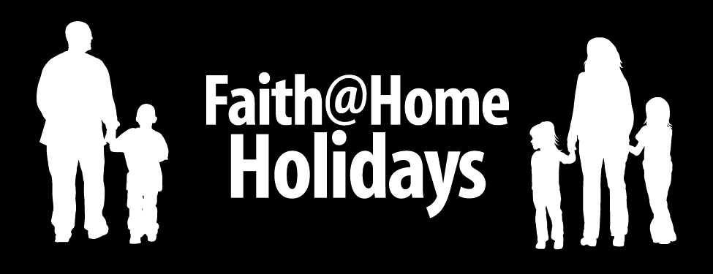

Best Use
As a Christmas family activity

Nutritional Value
Helping children connect the dots between the birth of baby Jesus and the reason He came.

Advance Preparation
Make sure you have the following on hand.
- A large piece of cardboard, scissors and tape
- A stack of index cards and pencils
- A red marker or crayon
- A Bible
Serve It Up
Follow these steps for a great experience…

- Before opening gifts have the children help you create a large cardboard cross. You can also use wooden boards to nail together if the children are old enough.

- Give each person a stack of index cards and a marker and invite them to write a word or draw a picture that represents something they do wrong that the Bible calls “sin.” Younger children might draw a mean face to represent temper tantrums or the word “NO” to represent disobedience.

- Ask the oldest child to read allowed Romans 3:23…

“For all have sinned and fall short of the glory of God.”

- Explain that sin means “to disobey God.” Then invite the oldest child to read Romans 3:23 allowed…

- Ask the children how many of us sin according to this verse. Then have the child read Romans 6:23 allowed…

“For the wages of sin is death, but the gift of God is eternal life in Christ Jesus our Lord.”

- Explain that “wages” means punishment. Then explain that the most important “gift” of Christmas is that Jesus came to pay the “wages” for our sin!

- Invite each person to tape or nail their index card “sins” to the cross while mom or dad reads John 3:16…

“For God so loved the world that he gave his one and only Son, that whoever believes in him shall not perish but have eternal life.”

- Now use a big red marker or crayon to write the word “Jesus” across each image and word on your cardboard cross, explaining that God no longer sees our sin. He only sees what Jesus did for us!

- Pray a prayer of thanks to God for the gift of Jesus and then memorize Romans 6:23 together.

© 2008 Inkling Innovations

