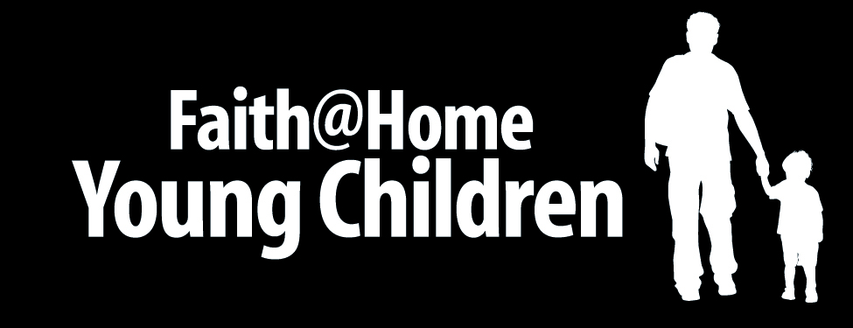

Good Friday

Best Use
As an Easter Week family activity

Nutritional Value
Understanding why Jesus died on a cross

Advance Preparation
Make sure you have the following on hand.
- A few long boards, nails and a hammer
- Pieces of craft or notebook paper and pencils or crayons
- A Bible

Serve It Up

Follow these steps for a great experience…
- First, ask one of the children to help you create a cross using the boards, hammer and nails.
- Next, call the family together and read Romans 3:23 from the Bible… “For all have sinned and fallen short of the glory of God.”
- Ask each person whether or not they have ever sinned. For younger children, explain the concept of sin as “when we do something wrong that goes against the good that God wants for us.”
- After discussing the concept of sin, invite each person to take a piece of paper and write words that represent some of the sins they have committed – such as lying, hitting, stealing, saying bad words, etc. Younger children can just draw a picture of a mean face, hitting another person, etc.
- Now invite an older child or parent to read Romans 6:23 and John 3:16 aloud.
- Invite each person to “nail their sins to the cross” to symbolize what happened when Jesus died for us.
- Once the sin pages are nailed to the cross, ask everyone to lay their hands on the cross and pray a brief prayer of thanks to God for what Jesus did for us on Good Friday.
- Memorize this jingle – “Jesus took my sins away, on the cross that Good Friday.”

© Kurt Bruner 2008

