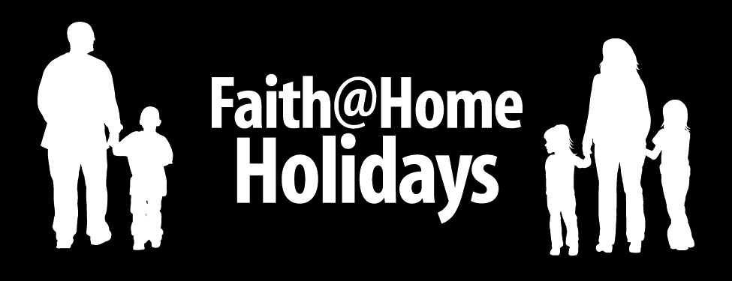

Pumpkin Parable

Best Use
As an activity tied to the Halloween season

Nutritional Value
Uses a holiday that emphasizes darkness to shine the light of Christ

Advance Preparation
Make sure you have the following on hand.
- A large pumpkin and carving utensils
- A small candle and matches
- A Bible

Serve It Up

Follow these steps for a great experience…

- Conduct a typical pumpkin carving activity, but use each step as part of the overall “pumpkin parable” by adding Bible reading and questions.
- First, have the children help with the clean out portion of the carving – reaching their hand into the open pumpkin to pull out seeds and other “gunk” that will feel yucky to their hands.
- Pause to read Matthew 23:25-28 and ask the children how the inside “gunk” is like our sin (yucky, smelly, etc.).
- Once you have cleaned out the pumpkin, read Revelation 3:20 together and explain that confessing our sins enables God to take away the “yuck” of our sinful hearts.
- Now draw and carve a happy face (not a scary face) on the pumpkin. Then read 2 Corinthians 5:17 and/or Ephesians 2:10 and explain that Jesus wants to make us into a “new creation” – just as the pumpkin filled with yuck became a jack-o-lantern with a joy-filled face.
- Now read Matthew 5:14-16 while lighting and inserting a candle into the jack-o-lantern and turn down the lights to show how God wants to use us to shine His light, even on what is normally a dark and scary night.
- Memorize the jingle – “On a dark and scary night, we will shine Jesus’ light!”

© Kurt Bruner 2008

