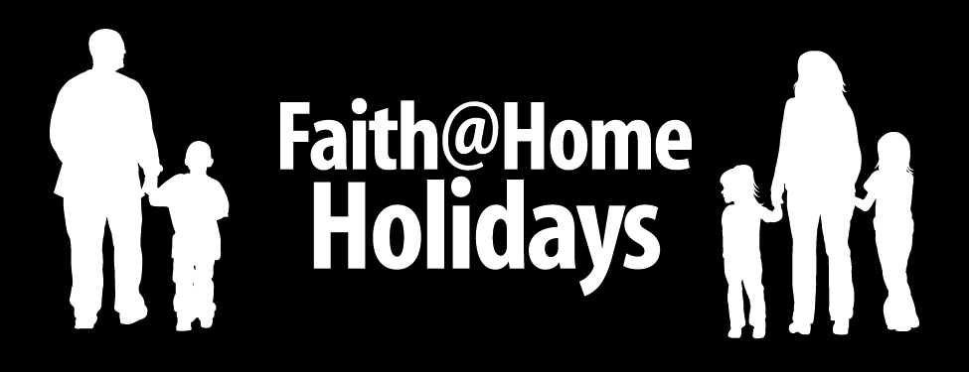

Attitude of Gratitude

Best Use
As a Thanksgiving Family Night activity

Nutritional Value
Learning to develop an attitude of gratitude

Advance Preparation
Make sure you have the following on hand.
- A glass of water
- Paper and crayons or markers
- Index cards
- A Bible

Serve It Up
Follow these steps for a great experience…

- Fill a glass of water half-way and place it on the table in front of the children.

- Give each child an index card with the phrase “The glass is half _______” written on it and ask them to complete the phrase.

- Once they’ve completed the phrase, go around and find out who wrote “full” and who wrote “empty” in the blank.

- Now give each child a piece of drawing paper and crayons. Ask them to draw a large glass half full of water. Ask them to spell the name or draw pictures of good things they already have (toys, books, family, food, clothes, etc.) in the portion of the picture WITH water.

- In the space WITHOUT water, have them write or draw things they would like to have such as more money, a new toy, a vacation to Disneyland, a special kind of cereal, or whatever they can think of.

- Read 1 Timothy 6:6-9 and Philippians 4:11-12 and discuss why it is important that we “learn” to be content no matter what we do or don’t have. Then read Ephesians 5:20 and explain that the practice of expressing thanks is one way we make our life “half full” instead of “half empty” because it helps us focus on the blessings God has given rather than complain about the things we don’t have.

- Wrap up your time by giving the children a stack of index cards and having them do a “Thanksgiving scavenger hunt” by running all over the house and identifying as many things for which they are thankful as they can in 10 minutes (or as long as you like). Let them write a word or draw a picture to represent each blessing.

- Gather back together and have the children pray a brief prayer of thanks for each card.

- Memorize the jingle – “I’ll be content with what God sent!”

MEMORY PANTRY: Attach a picture and jot down what happened to remember later or share a taste with others . . .
_____________________________________________________________
_____________________________________________________________
_____________________________________________________________

© Kurt Bruner 2008

